Exercise 1

Choose the most suitable future forms to complete the sentences below.

1Look! That car over there ….
a. will crash
b. is crashing
c. is going to crash..
2………….. the music down, please?
a. Are you going to turn
b.Are you turning
c. Will you turn..
3The film ………..at 5 p.m.
a. is going to start
b. starts..
c. is starting
4I'm sure you……… the lottery one day.
a. are winning
b. will win..
c. are going to win
5Don't you have any money on you? Don't worry, I ................ for the taxi.
a. ‘m paying
b. ‘ll pay..
c. ‘m going to pay
6According to my diary, we …………….the buyers at 7p.m. tomorrow.
a. are meeting..
b. will meet
c. meet
7It's cold. ……………… the heating on?
a. Am I going to turn
b. Do I turn
c. Shall I turn..
8I can't see you tomorrow. I ……………….football with my university friends.
a. play
b. will play
c. ‘m playing..
9A: Maria phoned you. B: OK. I ……….her back.
a. am going to call
b. will call..
c. am calling
10Thanks for the money. I ……………..you back on Friday.
a. will pay..
b. am paying
c. am going to pay

Check your answers:
1
Correct answer: is going to crash
➪ We use be going to to predict future events that are very near or we can see will happen (there is present evidence).
2
Correct answer: Will you turn
➪ We use will for offers and requests (when we ask someone to do something).
3
Correct answer: starts
➪ We use the present simple to refer to future events which are timetabled.
4
Correct answer: will win
➪ We use will to predict future events that we think will happen.
5
Correct answer: 'll play
➪ We use will to express instant decisions (decisions that we make at the moment of speaking).
6
Correct answer: are meeting
➪ We use the present continuous to talk or ask about future arrangements, i.e. future actions that are already planned or decided.
7
Correct answer: Shall I turn
➪ We use shall I or shall we to make offers and suggestions.
8
Correct answer: 'm playing
➪ We use the present continuous to talk or ask about future arrangements, i.e. future actions that are already planned or decided.
9
Correct answer: will call
➪ We use will to express instant decisions (decisions that we make at the moment of speaking).
10
Correct answer: will pay
➪ We use will for promises and refusals.

Exercise 2

Complete the dialogue with the most suitable future forms: present continuous, be going to, will, or shall.
Top of Form
Maria: What 1 (you/do) this evening? 2 (we/go out)?
Rosa: Not this evening. I 3 (work) on a project until late.
Maria: And when do you think you 4 (be) free for a drink?
Rosa: I don't know. I have my diary here with me; let me see. What about tomorrow? 5 (you/do) anything?
Maria: I 6 (see) my dentist tomorrow. Is Thursday OK?
Rosa: Yes, Thursday is perfect.
Maria: OK. What time 7 (we/meet)?
Rosa: I 8 (meet) a friend at 6. Is 7 OK?
Maria: Yes, great. But I don't have my car.
Rosa: Don't worry, I 9 (take) mine. 10 (I/pick you up) at 7 then?
Maria: OK, thanks.

Answers
1 Correct answer: are you doing/are you going to do
➪ We use the present continuous to talk or ask about future arrangements, i.e. future actions that are already planned or decided.
➪ We can also use be going to for plans and intentions.

2 Correct answer: Shall we go out
➪ We use shall I or shall we to make offers and suggestions.

3 Correct answer: am/'m going to work
➪ We use be going to for plans and intentions (decisions that have been already made).

4 Correct answer: will/'ll be
➪ We use will to predict future events that we think will happen.

5 Correct answer: Are you doing/Are you going to do
➪ We use the present continuous to talk or ask about future arrangements, i.e. future actions that are already planned or decided.
➪ We can also use be going to for plans and intentions.

6 Correct answer: am/'m seeing
➪ The verb see has a dynamic and a static sense. It is dynamic when it means ‘meet’, ‘have an appointment’, or ‘have a relationship with someone’.
➪ We use the present continuous to talk or ask about future arrangements, i.e. future actions that are already planned or decided.

7 Correct answer: shall we meet
➪ We use shall I or shall we to make offers and suggestions.

8 Correct answer: am/'m meeting
➪ We use the present continuous to talk or ask about future arrangements, i.e. future actions that are already planned or decided.

9 Correct answer: will/'ll take
➪ We use will to express instant decisions (decisions that we make at the moment of speaking).

10 Correct answer: Shall I pick you up
➪ We use shall I or shall we to make offers and suggestions.
Công thức

Future forms – summary chart
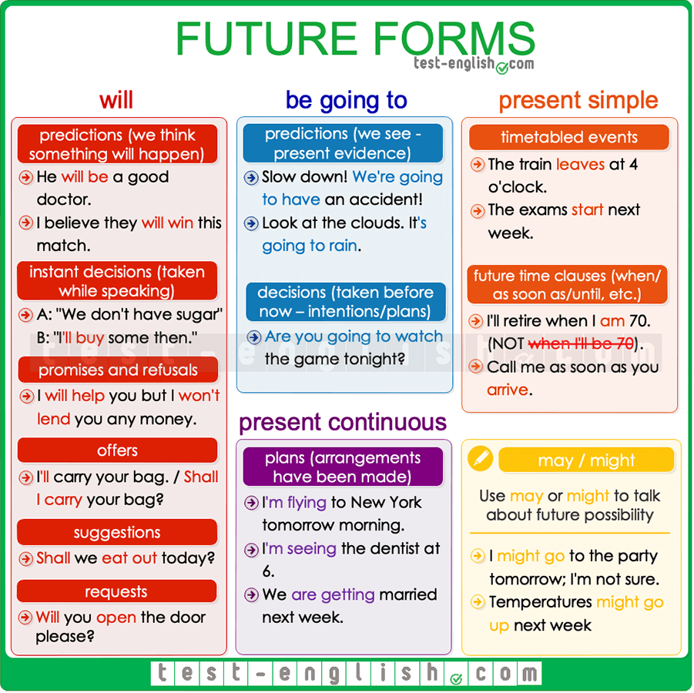

Predictions
We use will to talk about something we think that will happen:
- I think he’ll win the election.
- He will be a good doctor.
We use be going to to talk about something that is very near to happen or that we see is going to happen (there is present evidence)
- Don’t drive like a crazy man. We’re going to have an accident!
- The doctor said I’m going to have a girl.

Decisions
We use will for decisions that we take at the moment of speaking (instant decisions).
- ‘Oh, we don’t have sugar.’ ‘Don’t worry, I’ll buy some.’
We use be going to for decisions that we have already taken at the moment of speaking (intentions or plans).
- ‘Why are you undressing?’ ‘Because I’m going to go to the swimming pool.’

Arrangements
We often use the present continuous to talk about future events that are already planned or decided. When we use the present continuous for arrangements, we must always include when (at 7, this evening, next month, etc.) in the sentence.
- I’m seeing the dentist at 6.
- We are getting married next week.
- I’m flying to New York tomorrow morning.
We can also use be going to for future arrangements.
- I’m going to play tennis with Elisabeth today.

Future time clauses (when, as soon as, until, before, after)
Use the present simple to talk about the future in sentences with when, as soon as, until, before, after.
- I’ll retire when I’m 70. (NOT when I’ll be)
- I won’t call you until I arrive (NOT will arrive.)

Other uses of will

Promises and refusals

- I will help you whenever you need me.
- I won’t lend him my car.

Future facts

- The president will visit the Vatican next November.

Offers
We use I will in statements or shall I in questions.
- I’ll carry that bag for you.
- Shall I organise the meeting?

Suggestions
We use shall we…?
- Shall we eat out today?

Requests
When we ask someone to do something for us.
- Will you open the door, please?

may or might as a future form
We use may or might for possible actions in the future (when ‘we are not sure’). Compare:
- I’ll be late for dinner today. (=I am sure.)
- I might be late for dinner today. (=It’s possible, but I am not sure.)
- I’m going to Denmark next September. (=Sure.)
- I might go to Denmark next September. (=Not sure.)
We use may or might for things that will possibly happen in the future, but we are not too sure. It’s like a prediction about something that we think perhaps will happen.
- The economy might suffer a global recession next year.
- Temperatures may go up next week.
We use may or might not for actions or things that will possibly not happen.
- She looks very tired. She might not come with us.
- We may not have enough time to finish the report for tomorrow.

Bottom of Form

