Thì Hiện tại Hoàn thành Tiếp diễn - Present perfect continuous

*I. Ôn lại thì Hiện tại Hoàn thành
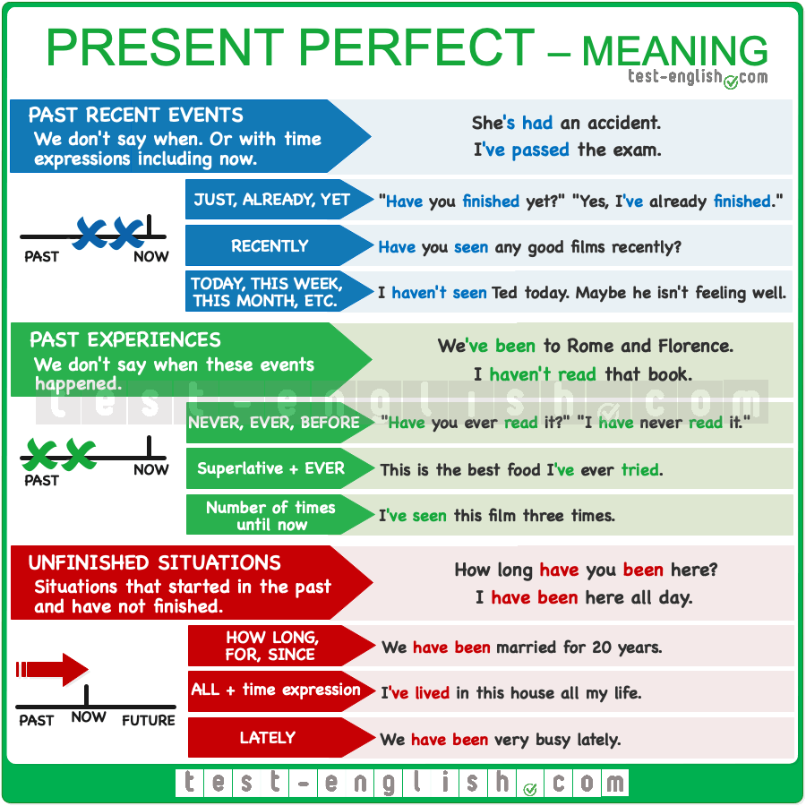
We use the present perfect simple with past finished actions or experiences when we don’t mention or we don’t know when they happened. And we also use the present perfect simple to ask or talk about situations that started in the past and have not finished.
Chúng ta sử dụng thì hiện tại hoàn thành đơn giản với các hành động hoặc trải nghiệm đã hoàn thành trong quá khứ mà chúng ta không đề cập đến hoặc chúng ta không biết khi nào chúng xảy ra. Và chúng ta cũng sử dụng thì hiện tại hoàn thành đơn giản để hỏi hoặc nói về những tình huống đã bắt đầu trong quá khứ và chưa kết thúc.

*II. Công thức Present perfect continuous
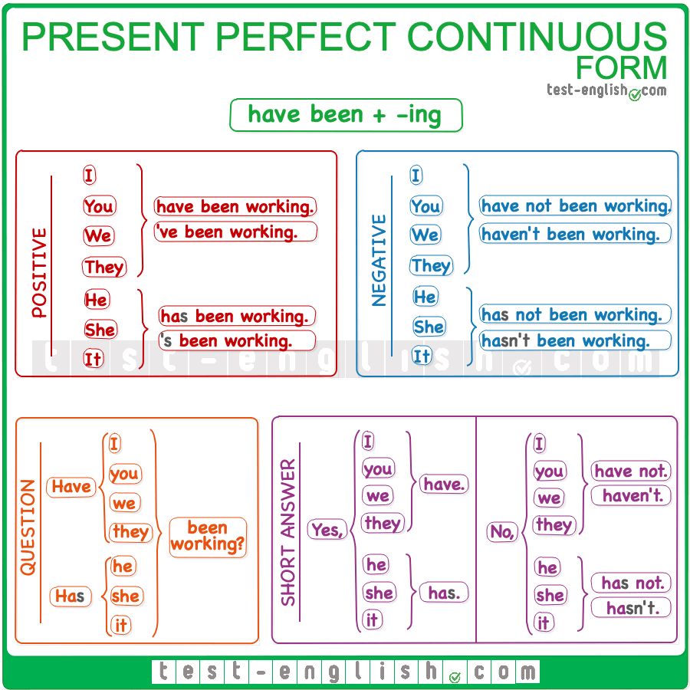
We form the present perfect continuous with the present perfect simple of be + the -ing form of the main verb.

Cách sử dụng Present perfect continuous

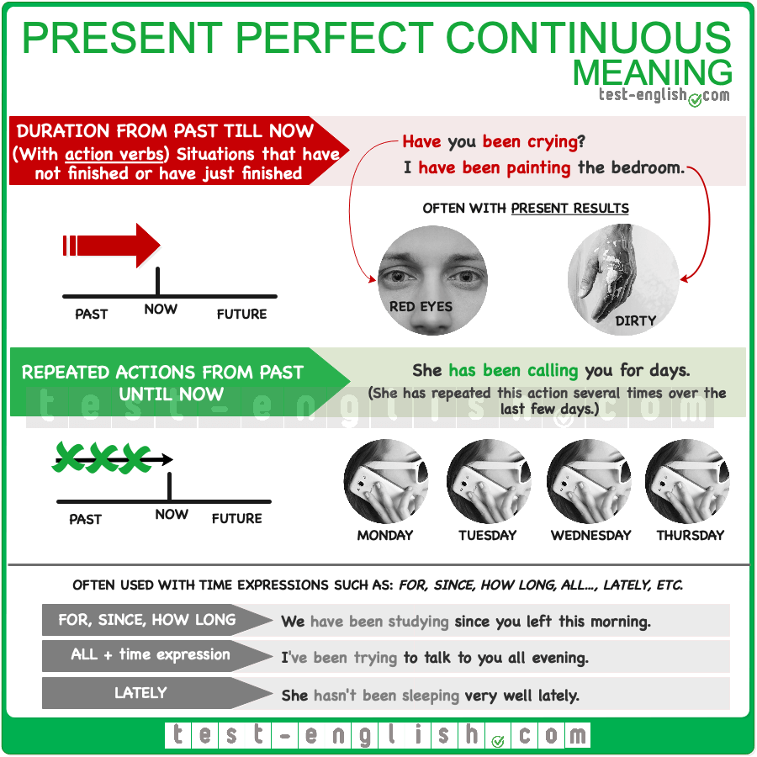

Actions from the past till now – duration
We use the present perfect continuous with action verbs (dynamic verbs) to talk about situations that started in the past and have not finished or have just finished.
Chúng ta sử dụng thì hiện tại hoàn thành tiếp diễn với các động từ hành động (động từ) để nói về các tình huống bắt đầu trong quá khứ và chưa kết thúc hoặc vừa kết thúc.
- Have you been crying?
- Sorry I am so dirty, but I‘ve been painting.
There is often a present result from doing these actions.
Thường có một kết quả hiện tại từ việc thực hiện những hành động này.

- You‘ve been crying. (Your eyes are red.)
- I am dirty because I‘ve been painting.
We can use the present perfect continuous to talk about continuous or repeated actions or situations from the past till now.
Chúng ta có thể sử dụng thì hiện tại hoàn thành tiếp diễn để nói về các hành động hoặc tình huống liên tục hoặc lặp đi lặp lại từ quá khứ đến nay.
- She‘s been calling you for days. (=She has repeated this action for several days.)
- I‘ve been studying since you left. (=I have done this action continuously without stopping.)

Các từ dấu hiệu

for, since, how long, lately, all day/week/month/etc.
We can use for, since, how long, lately, all day/week/month/etc. to ask or say how long a situation has been happening.
- I haven’t been feeling well lately.
- He’s been annoying us all evening.
- She’s been studying very hard for weeks.
- How long have you been playing golf?

Khi nào dùng HTHT và khi nào dùng HTHTTD?

Situations that started in the past and still continue
We can use the present perfect simple and the present perfect continuous to talk about situations that started in the past and still continue. But we must use the present perfect simple with non-action verbs (stative verbs), and we normally use the present perfect continuous with dynamic verbs (although the present perfect simple is also possible.)

Các tình huống đã bắt đầu trong quá khứ và vẫn tiếp tục
Chúng ta có thể sử dụng thì hiện tại hoàn thành và hiện tại hoàn thành tiếp diễn để nói về các tình huống đã bắt đầu trong quá khứ và vẫn tiếp diễn. Nhưng chúng ta phải sử dụng thì hiện tại hoàn thành với các động từ không phải hành động (động từ chỉ tính chất trạng thái, ví dụ: Think: nghĩ, Believe: tin, Imagine: tưởng tượng, Know: biết, Understand: hiểu), và chúng ta thường sử dụng thì hiện tại hoàn thành tiếp diễn với động từ chỉ hành động (mặc dù hiện tại hoàn thành cũng có thể được dùng).
- We‘ve had this car for years.
- I haven’t been sleeping well lately.
We use the present perfect continuous (and NOT simple) with dynamic verbs for situations that started in the past and still continue when we want to emphasise how long the situation has lasted.
Chúng ta sử dụng thì hiện tại hoàn thành tiếp diễn (KHÔNG phải thì HTHT) với động từ động cho các tình huống đã bắt đầu trong quá khứ và vẫn tiếp diễn khi chúng ta muốn nhấn mạnh tình huống đó đã kéo dài bao lâu.
- I have been waiting for hours! (=I want to emphasise that I’ve been waiting for a long time).
- I couldn’t do the dishes. I’ve been working all day.

Finished and unfinished situations
We use the present perfect simple for finished actions in the past when we don’t say when. We use the present perfect continuous for actions or situations that maybe have not finished or that maybe have finished (very recently)

Tình huống đã hoàn thành và chưa hoàn thành
Chúng ta sử dụng thì hiện tại hoàn thành cho các hành động đã hoàn thành trong quá khứ mà chúng ta không nói khi nào chúng hoàn thành. Chúng ta sử dụng thì hiện tại hoàn thành tiếp diễn cho các hành động hoặc tình huống có thể chưa kết thúc hoặc có thể đã kết thúc (rất gần đây)
- Who has eaten my cookies? (=We would say this if there are no cookies left. The action is finished.
- Who has been eating my cookies? (=We would say this if there are some cookies left)
- I‘ve been watching the series you recommended. I’ll tell you about it when I finish watching it.
- I‘ve watched the series you recommended. I watched the last episode yesterday.

Actions with present results
We can use present perfect simple and present perfect continuous for actions with present results. We use the present perfect simple if the present results come from completing the action.

Hành động với kết quả hiện tại
Chúng ta có thể sử dụng thì hiện tại hoàn thành và HTHTTD cho các hành động có kết quả hiện tại. Chúng ta sử dụng thì hiện tại hoàn thành nếu kết quả hiện tại đến từ việc hoàn thành hành động.
- Look how nice my car looks. I‘ve washed it. (=The car looks nice because I have finished washing it.)
- Something is different in this house. Have you painted it? (=The house looks different because you have completed the action of painting it.)
We use the present perfect continuous if the present results come from the process of doing the action.
Chúng ta sử dụng thì hiện tại hoàn thành tiếp diễn nếu kết quả hiện tại đến từ quá trình thực hiện hành động.
- Sorry I’m so sweaty. I‘ve been washing my car. (=I am sweaty because of the physical activity that washing the car involves.)
- How come you are so dirty? Have you been painting? (=You are dirty because of the process of painting.)

how long vs how many/much
We use the present perfect continuous to talk about the duration of an action, i.e. about how long we have been doing something. And we use the present perfect simple to talk about how many things or how much of something we have done.
Chúng ta sử dụng thì hiện tại hoàn thành tiếp diễn để nói về khoảng thời gian của một hành động, tức là chúng ta đã làm một việc gì đó trong bao lâu. Và chúng ta sử dụng thì hiện tại hoàn thành để nói về bao nhiêu việc hoặc bao nhiêu điều chúng ta đã làm.
- I’ve written twenty e-mails. (I’m talking about how many emails I’ve written.)
- I’ve been writing emails for hours. (=I’m talking about how long I have spend writing emails)

*III. BÀI TẬP

Exercise 1

Choose the present perfect simple or present perfect continuous to complete the sentences below. If both tenses are possible, use the present perfect continuous.
Top of Form
1I and my legs are really tired now.
a. ‘ve cycled
b. ‘ve been cycling
2I'm sorry I'm late, for a long time?
a. have you waited
b. have you been waiting
3How long Peter?
a. have you known
b. have you been knowing
4Somebody my cookies. There are none left.
a. has been eating
b. has eaten
5Somebody my cookies. There are very few left.
a. has eaten
b. has been eating
6How many books ?
a. has she been writing
b. has she written
7She must be tired. She all afternoon.
a. has written
b. has been written
8I all afternoon? I 5 chapters.
a. ‘ve been reading a. ‘ve read
b. ‘ve read b. ‘ve been reading
9I think I chocolate since I was born.
a. ‘ve been liking
b. ‘ve liked
10They for months, and they three countries so far.
a. have travelled have visited
b. have been travelling have been visiting

Exercise 2

Choose the present perfect simple or present perfect continuous for each gap below.
Top of Form
Page 1 of 2
1I ______ the book you lent me and it's great. I'll give it back to you when I finish it.
a.'ve read
b.was read
c.'ve been reading
2Bruce ______ tennis since he was a child. He ______ many trophies.
a.has been playing / has won
b.is playing / has won
c.has played / has been winning
3You ______ too much time playing that stupid game!
a.'ve spent
b.'ve spending
c.'ve been spending
4You ______ tennis since 10 o'clock. How many sets ______ ?
a.have played / have you been playing
b.have been playing / have you played
c.are playing / have you played
5He ______ since he was a little boy. Choose TWO correct options
a.is fishing
b.has fished
c.has been fishing

Exercise 3

Complete the dialogues below with the present perfect simple or present perfect continuous of the verbs in brackets. If both tenses are possible, use the present perfect continuous.
Top of Form
1A: I'm very tired. We (walk) too fast.
B: Maybe you are right, we (walk) 10 kilometres in only one hour and a half.
2A: You (drink). You can't take the car.
B: But I (only/drink) a couple of beers!
A: That isn't true; you (drink) four beers.
3I (wait) for you all morning! Where (you/be) all this time?
4I (teach) in this school for 20 years, and I (meet) thousands of students from hundreds of different countries.
5A: It smells fantastic!
B: Yeah, I (make) cookies all afternoon.
A: Let me see. Wow! You (make) a lot of cookies!
6A: Someone (call) all morning. They (call) at least ten times.
B: Well, you (sit) next to the phone all this time. You could have picked it up.
7I (work) here for over a month and I (not meet) the manager yet.
8I (lose) my keys and I (try) to contact my wife all morning, but she isn't answering her phone.
9What's the matter with you? You (say) anything since this morning.
10Look, I (wash) my car. Doesn't it look new now?
KEY
Exercise 1
1
Correct answer: 've you been cycling
➪ We use the present perfect continuous with dynamic verbs for situations which started in the past and have not finished or have just finished.
➪ We use the present perfect continuous when the present result comes from the process of doing the action: my legs are tired because I have been cycling.
2
Correct answer: have you been waiting
➪ We can use both the present perfect simple or continuous to talk about situations that started in the past and have not finished, but the present perfect continuous is more common when the verb is dynamic (action verbs).
3
Correct answer: have you known
➪ We can use both the present perfect simple and the present perfect continuous with how long, for, since, recently, lately to talk about situations that started in the past and still continue.
➪ But we can only use the present perfect simple with stative verbs, and know is a stative verb.
4
Correct answer: has eaten
➪ When we use the present perfect simple for a past finished action, we focus on the completion of the action; i.e. the action has been completed (=there are no cookies left). When we use the present perfect continuous we focus on the duration of the action; the action has been going on for some time and maybe it's been completed or maybe not.
5
Correct answer: has been eating
➪ When we use the present perfect simple, we focus on the completion of the action, i.e. the action has been finished . And when we use the present perfect continuouss we focus on the duration of the action; the action has been going on for some time and maybe it’s been finished or maybe not. If there are some cookies left, it means that the action has not been completed, and this is why we need the present perfect continuous.
6
Correct answer: has she written
➪ We use the present perfect simple to talk about how many things or how much of something we have done (how many books).
7
Correct answer: has been writing
➪ We use the present perfect continuous with action verbs (dynamic verbs) to talk about situations that started in the past and have not finished or have just finished.
➪ With the present perfect continuous, we emphasise the duration of the action: we have been doing something all morning, all day, etc.
8
Correct answer: 've been reading/'ve read
➪ We use the present perfect continuous with dynamic verbs for situations which started in the past and are still going on or have just finished. We focus on the duration of the action (all afternoon).
➪ We use the present perfect simple when we talk about how many things or how much of something we have completed (how many chapters); we are focusing on the completion of the action.
9
Correct answer: 've liked
➪ We can use both the present perfect simple and the present perfect continuous with how long, for, since, recently, lately to talk about situations that started in the past and still continue.
➪ But we can only use the present perfect simple with stative verbs, and like is a stative verb.
10
Correct answer: have been travelling/have visited
➪ We use the present perfect continuous with action verbs (dynamic verbs) to talk about situations that started in the past and have not finished or have just finished. In this sentence the verb travel is dynamic and we focus on the duration of the action (for months).
➪ We use the present perfect simple to talk about how many things or how much of something we have done. We focus on the completion of the action, i.e. how many things we have finished doing.
Exercise 2
- C
- A
- C
- B
- b
Exercise 3
1
Correct answer (1st gap): have been walking ('ve been walking)
➪ We use the present perfect continuous with dynamic verbs for situations which started in the past and are still going on or have just finished. There’s normally a present result (I'm tired) that comes from the process of doing the action.
Correct answer (2nd gap): have walked ('ve walked)
➪ We use the present perfect simple when we talk about how many things or how much of something we have done (10 kilometres), because we are focusing on the completion of the action.
2
Correct answer (1st gap): have been drinking ('ve been drinking)
➪ We use the present perfect continuous with dynamic verbs for situations which started in the past and are still going on or have just finished. There’s normally a present result (=You are too drunk to drive) that comes from the process of doing the action.
Correct answer (2nd gap): have only drunk ('ve only drunk)
➪ We use the present perfect simple when we talk about how many things or how much of something we have done (a couple of beers), because we are focusing on the completion of the action.
Correct answer (3rd gap): have drunk (have drunk)
➪ We use the present perfect simple when we talk about how many things or how much of something we have done (four beers), because we are focusing on the completion of the action.
3
Correct answer (1st gap): have been waiting ('ve been waiting)
➪ We use the present perfect continuous with dynamic verbs and expressions like how long, for, since, all ..., lately, to talk about situations which started in the past and are still going on or have just finished.
Correct answer (2nd gap): have you been
➪ We use the present perfect simple with stative verbs and expressions like how long, for, since, all ..., lately, to talk about situations which started in the past and are still going on or have just finished. Be is a stative verb.
4
Correct answer (1st gap): have been teaching ('ve been teaching)
➪ We use the present perfect continuous with dynamic verbs and expressions like how long, for, since, all ..., lately, to talk about situations which started in the past and are still going on or have just finished.
Correct answer (2nd gap): have met ('ve met)
➪ We use the present perfect simple when we talk about how many things or how much of something we have done (thousands of students), because we are focusing on the completion of the action.
5
Correct answer (1st gap): have been making ('ve been making)
➪ We use the present perfect continuous with dynamic verbs and expressions like how long, for, since, all …, lately, to talk about situations which started in the past and are still going on or have just finished.
11 Correct answer (2nd gap): have made ('ve made)
➪ We use the present perfect simple when we talk about how many things or how much of something we have done (a lot of cookies), because we are focusing on the completion of the action.
6
Correct answer (1st gap): has been calling ('s been calling)
➪ We use the present perfect continuous with dynamic verbs and expressions like how long, for, since, all …, lately, to talk about situations which started in the past and are still going on or have just finished.
Correct answer (2nd gap): have called ('ve called)
➪ We use the present perfect simple when we talk about how many things or how much of something we have done (ten times), because we are focusing on the completion of the action.
Correct answer (3rd gap): have been sitting ('ve been sitting)
➪ We use the present perfect continuous with dynamic verbs and expressions like how long, for, since, all …, lately, to talk about situations which started in the past and are still going on or have just finished.
7
Correct answer (1st gap): have been working ('ve been working)
➪ We use the present perfect continuous with dynamic verbs and expressions like how long, for, since, all …, lately, to talk about situations which started in the past and are still going on or have just finished.
Correct answer (2nd gap): have not met (haven't met)
➪ We often use the present perfect simple with just, already and yet.
8
Correct answer (1st gap): have lost ('ve lost)
➪ We use the present perfect simple for single past actions with a present result (=I don't have my keys now) when we don't say when they happened. We use the present perfect continuous to talk about continuous or repeated actions or situations from the past till now. If we say I've been loosing my keys we mean that I have lost them several times from the past till now.
Correct answer (2nd gap): have been trying ('ve been trying)
➪ We use the present perfect continuous with dynamic verbs and expressions like how long, for, since, all …, lately, to talk about situations which started in the past and are still going on or have just finished.
9
Correct answer: have not said (haven't said)
➪ We use the present perfect simple when we talk about how many things or how much of something we have done (anything), because we are focusing on the completion of the action.
10
Correct answer: have washed ('ve washed)
➪ We use the present perfect simple to talk about recent actions with present results when the present result comes from completing the action: the car looks like new because I have finished cleaning it.

Bottom of Form
Bottom of Form
Bottom of Form

